**ASSIGNMENT 10.2**

1.The database custom is created by using the keyword create database.

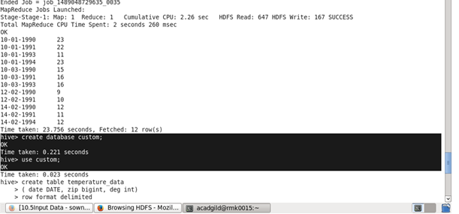

2.Create a table named temperature_data inside custom database.

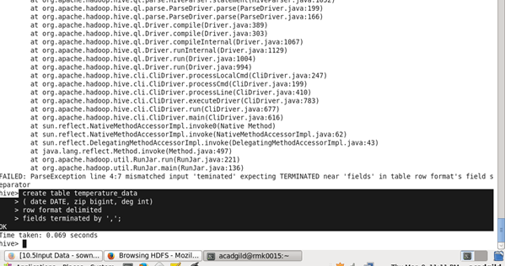

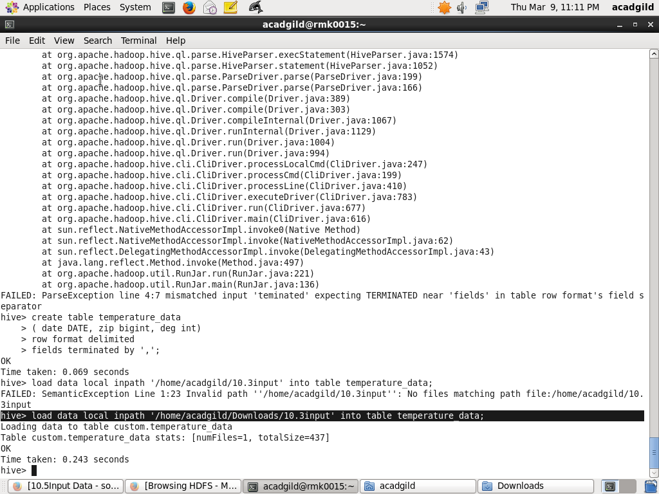

OUTPUT:

The table temperature_data has been created inside the data base custom.

